NAME:NANDHIKA G

REG NO:727721EUIT097

SOFTWARE TESTING CC2

YATRA:

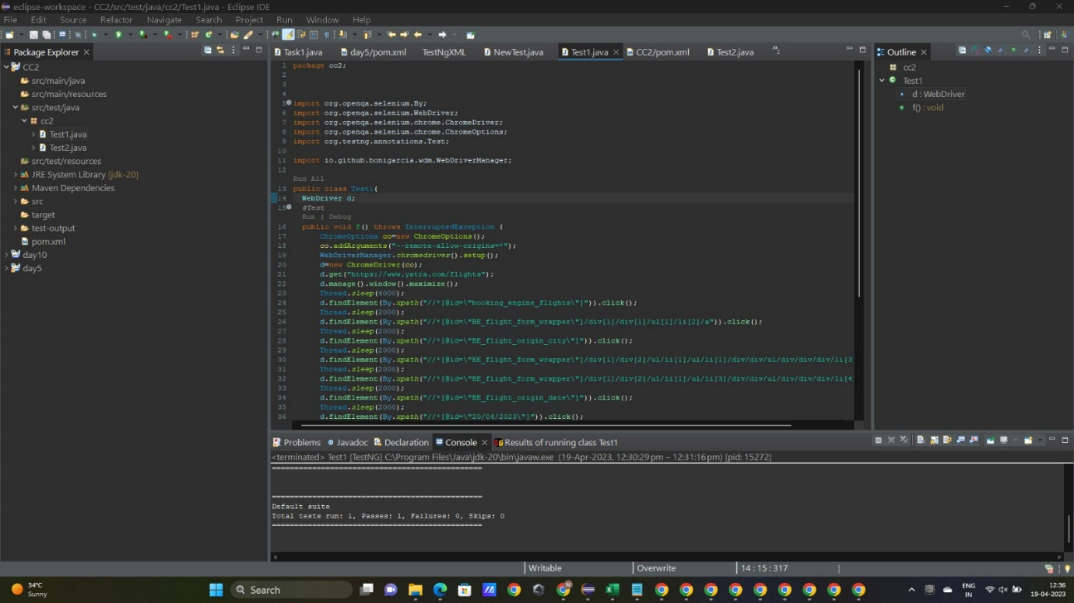



OUTPUT:

